Treatment Care Soap AH
Soap with excellent cleansing and antiseptic properties, suitable for whitening, improves the absorption of active ingredients.
Contains: Alpha Hydroxy Acid (AHA) Suitable for all skin types.
Ref.: 5001 - 250 ml

Unique Soap
A gentle soap that is pH balanced for the skin (pH 5.5).
The soap has antiseptic properties and does not irritate the skin. It penetrates pores, breaks down oils and is non-drying.
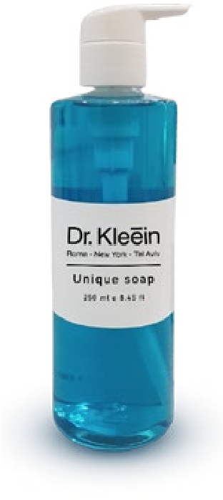
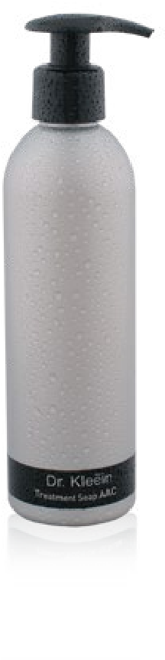
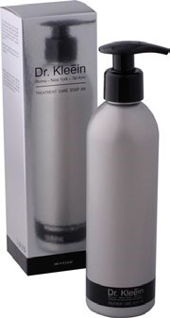
Contains: an Herbaceous foaming Saponin (Saponaria), Aloe Vera Extract, Green Tea extract, Sorbitol (a natural compound found in Seaweed), and Glycerin (a Humectant that prevents dryness).
Category: Soaps
Suitable for normal, delicate and dry skin.
Ref.: 60003 - 250 ml

Treatment Soap AAC
An antiseptic and Anti-bacterial therapeutic soap (with cleansing and purifying properties), removes dead skin cells, dissolves oils, and whitens.
Contains: Azelaic Acid, Mandelic Acid, Lactic Acid, and Glycolic Acid.
The soap is suitable for normal or oily skin and for men’s post-shaving skin care.
Ref.: 5002 - 250 ml

Category: Masks

Argil Klein Mask
A unique mask whose formula specifically treats problems with acneprone and oily skin. Soothing, antiseptic, and anti-inflammatory.
Contains: Green Clay- which is naturally rich in powerful minerals that absorb toxins, treat infections, and purify the skin from pollutants. Lemon Oil, Pink Grapefruit Oil, and Orange Oil- which help to balance sebum secretions and to heal lesions.
Suitable for oily and acne-prone skin.
Ref.: 81005 - 50 ml Ref.: 50007 - 250 ml

Total Vital Mask
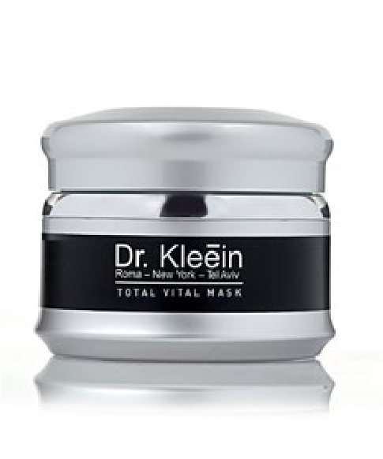
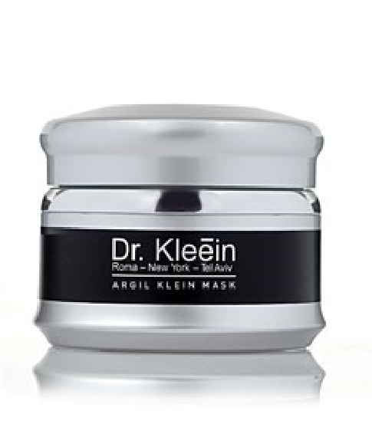
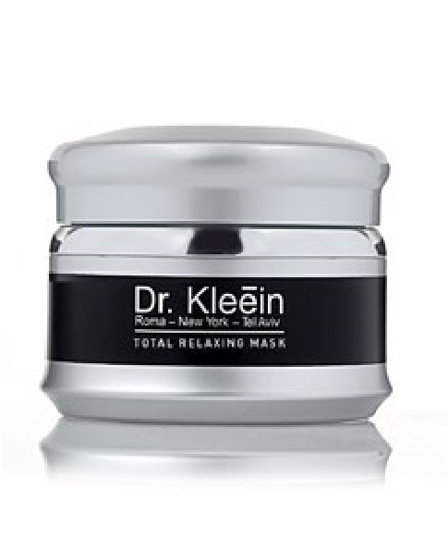
A mask specifically formulated for dry, sensitive and damaged skin types. The lifting effect counters skin aging
Contains: Anti-Oxidants and moisturizers such as: Hyaluronic Acid, Urea, Calendula Extract, Lactic Acid, and Vitamin E, which improves the skin’s suppleness, giving it a velvety appearance.
Suitable for dry skin, dehydrated skin and aging skin.
Ref.: 81021 - 50 ml Ref.: 70010 - 250 ml

Total Relaxing Mask
A therapeutic mask that calms redness and puffiness. Regulates sebum secretion, cleanses, purifies, and whitens. Leaves skin feeling comfortable and soft.
Contains: Plant-Based whitening ingredients, including Lactic Acid, Licorice and Mulberry Extract.
Suitable for all skin types.
Ref.: 81020 - 50 ml
Ref.: 70011 - 250 ml

Resveratrol Proactive Mask
The mask is rich in moisture and Resveratrol- a strong Anti-Oxidant found in the skin of grapes and in red wine. The mask was developed especially to help nourish the skin, maintain vitality and suppleness as well as give an immediate radiant effect and a smooth and silky feel.
Contains: Hyaluronic Acid, Ester C, Vitamin E, Coconut Oil, Palm, Avocado, Rosehip and more.
**Paraben-free**
The mask is suitable for dry skin.
Ref.: 80005 - 50 ml
Ref.: 50020 - 250 ml

Instant Up Lifting Mask
A lifting mask that works immediately to give a long-lasting effect. No need to rinse. For dry and mature skin and can be used as a rich night cream. Helps to minimize the appearance of fine lines and wrinkles, makes skin look and feel smooth, firm and lifted.
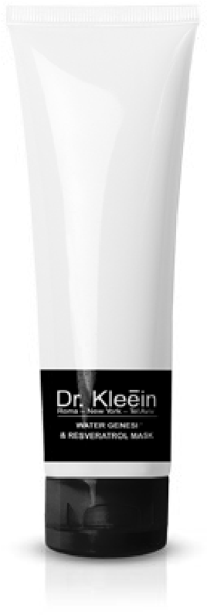
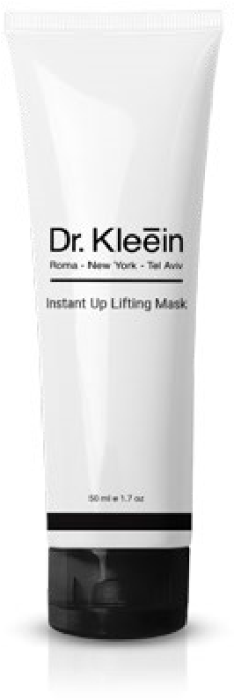
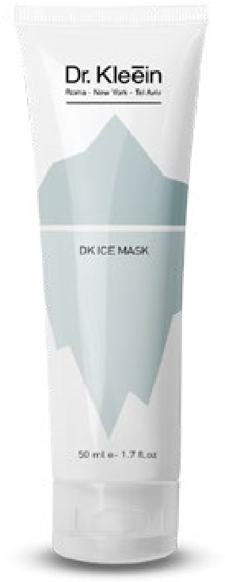
contains: a blend of unique Peptides, a complex of natural Oils - Wheat Germ, Avocado, Jojoba, and squalene from olives, Hyaluronic Acid, Glycosaminoglycan, Quillaja and Kigelia extract.
Recommended for use before an event and also as a rich night cream.
Suitable for mature skin
Ref.: 81029 - 50 ml

DK Ice Mask
A peptide-based cooling mask that contains a synergistic blend of ingredients that combines several skin cooling mechanisms to achieve an optimal effect in a short time. Lowers skin temperature by 7° and brings it to a pH level of 5.5. Lowers sebum secretion and strengthens collagen fibers. Firms and protects against pollutants, gives an immediate lifting effect that lasts for several hours.
contains: a blend of Biometric Peptides, Glycosaminoglycan, Palmitoyl Tripeptide-8, a blend of Palmitoyl Oligopeptide + Palmitoyl
Tetrapeptide-7, Witch Hazel water, Chamomile extract, Licorice extract, Canadian willowherb, Aloe Vera gel, Allantoin, Hyaluronic acid, Menthol and Menthyl lactate.
Suitable for all skin types.
Ref.: 81036 - 50 ml
Ref.: 81033 - 250 ml

Category: Eyes

Unique Eye Mask
A special treatment for the eye area. Does not require rinsing! Based on Peptides. Helps to minimize puffiness and deliver concentrated moisture. Leaves skin looking smooth and protects the suppleness and firmness around the eyes. Rich in Anti-Oxidants to maintain the skin’s resilience and prevent premature aging.
Contains: mixture of Peptides and Anti-Oxidants.
The mask is suitable for all skin types.
Ref.: 81034 - 30 ml

Active Eye Cream
A gentle and rehabilitating cream that treats the area around the eyes.
The formula contains concentrated active ingredients.
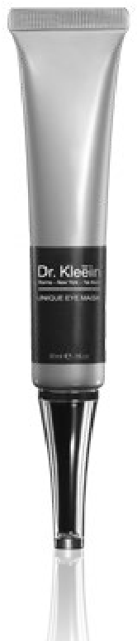
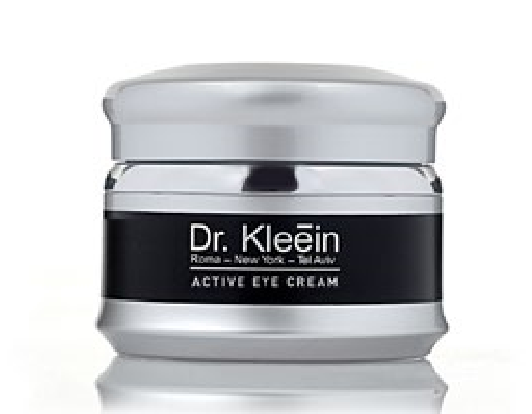
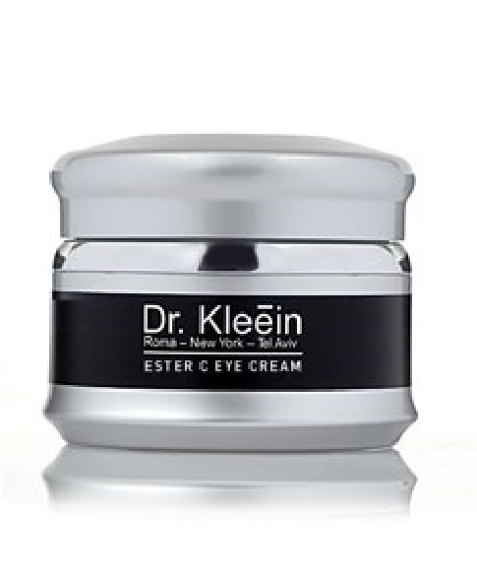
Treats signs of fatigue, reduces puffiness and dark circles, moisturizes and minimizes wrinkles, while promoting regeneration.
Contains: Soy, Vitamin E, Vitamin B5 and Minerals.
Suitable for all skin types.
Ref.: 81001 - 15 ml Ref.: 70006 - 250 ml

Ester C Eye Cream
A very delicate and nourishing cream that is easily absorbed and provides the delicate skin around the eyes with moisture and protection. Promotes cell regeneration, smoothens, brightens, and protects against environmental damage.
Contains: Ester C, Vitamin E and Vitamin B to strengthen blood vessels.
Suitable for all skin types.
Ref.: 81007 - 15 ml
Ref.: 70012 - 250 ml

Category: Moisturizers

Active Hydration N/O
A delicate therapeutic cream that is suitable for any oily skin, both young and mature. Recommended for use during periods when the patient is taking Roaccutane.
Promotes scabbing, healing, soothes, prevents irritation, and speeds the healing process.
Contains: Allantoin (heals and soothes) and Vitamin B5, which promotes natural skin healing.
Suitable for oily skin.
Ref.: 81004 - 50 ml
Ref.: 81004 - 250 ml

Active Nourishing Moist
A rich, healing and antiseptic nourishing cream.
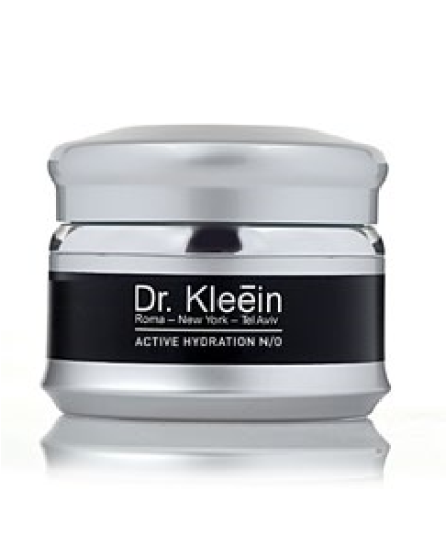
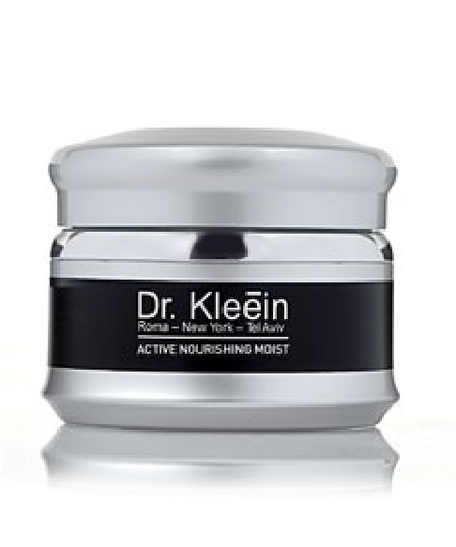
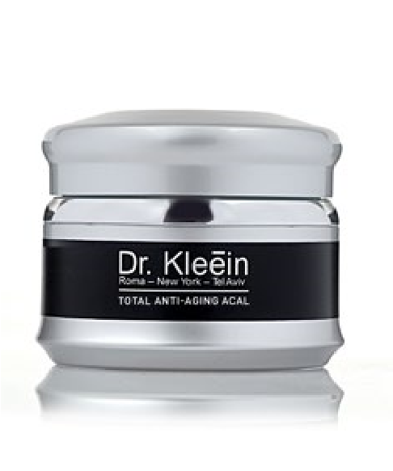
Contains: Natural ingredients, oils, extracts, and Plant-based Vitamins: A, C, E, Shea Butter, Omega 3, Borage Oil (Botanical Oil, Anti-Oxidant), Calendula Oil, Evening primrose Oil and more.
Suitable for dry and very dry skin, and in acute conditions that require healing, nourishing, and repair, particularly rehabilitation after peeling.
Ref.: 81013 - 50 ml
Ref.: 50009 - 250 ml

Total Anti-Aging ACAL
A rich yet delicately textured cream with high concentrations of active anti-oxidants. The alpha lipoic acid promotes skin cell regeneration and prevents pigmentation spots.
The cream heals, nourishes, moisturizes and mainly protects against harmful environmental elements. Daily use with leave skin looking healthy and radiant, and slow the skin aging process.
Contains: Alpha Lipoic Acid (Microcapsules), Vitamin E, Lactic Acid, and Ester C.
Suitable for normal and dry skin, particularly skin in need of rehabilitation.
Ref.: 81019 - 50 ml
Ref.: 70014 - 250 ml

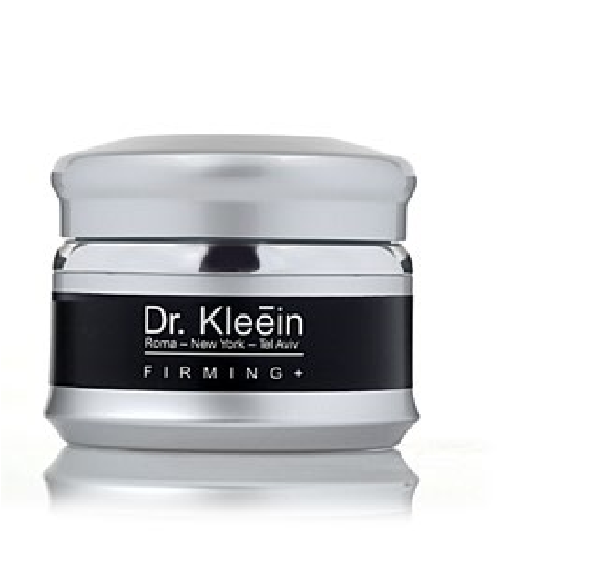
Firming +
A rich and multi-purpose moisturizing and nourishing cream that affects the skin tissues in several ways:
Regeneration - stimulates regeneration of the skin’s tissue, balances mineral levels in the skin, increased nourishment and moisture, rehabilitation, soothes, and stimulates cell regeneration.
Contains: encapsulated Vitamins A and E, Vitamin B5, Dead Sea Minerals, Lactic Acid, Pomegranate Extract, Urea and Allantoin.
Suitable for dry to very dry skin. Ref.: 81028 - 50 ml

Post Protective SPF 50
A rich moisturizing and nourishing cream based only on natural ingredients with a high SPF of 50.
Contains: protective and Anti-Oxidant ingredients that complete the skin’s defensive and healing actions, including: Shea Butter, Vitamins C, E, Calendula Oil, Rosehip (produced from rosehip seeds to improve skin texture), Jojoba, Evening Primrose, and Green Tea Extract.
Suitable for normal skin.
Ref.: 81012 - 50 ml
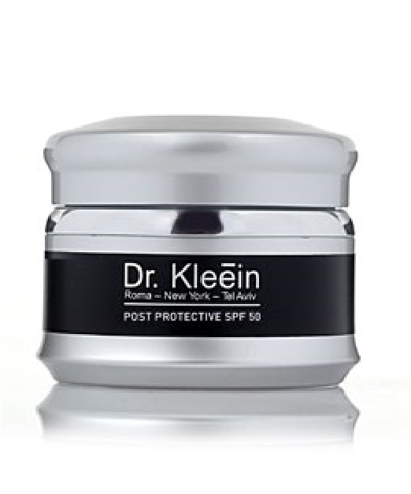
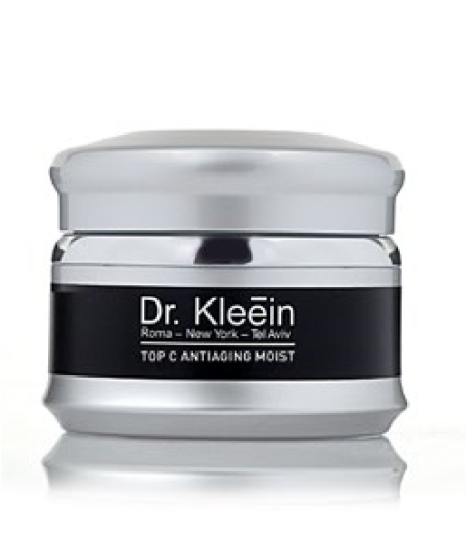
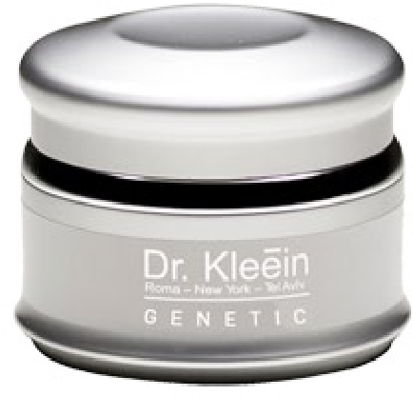
Ref.: 50008 - 250 ml

Top C Anti-Aging Moisturizer
A moisturizing product with strong anti-oxidant action. Based on ester C. The cream is rich in active ingredients that deliver moisture throughout the day.
Contains: Vitamins B and E, and Lactic Acid, which have an accelerated action due to being in the presence of the Ester C.
Suitable for normal to dry skin.
Ref.: 81018 - 50 ml
Ref.: 70008 - 250 ml

Genetic Intensive Prive' Lifting
An active and multi-purpose unique product based on revolutionary ingredients using nanotechnology, enabling focused penetration to the deep layers of the skin. Encourages subcutaneous activity (in the dermis layer) that manifests in building new collagen and elastin fibers, thanks to a revolutionary DNA component that can repair the skin and improve its elasticity! Regular use will result in a significant reduction of wrinkle depth, a significant improvement of moisture levels and in the skin’s overall appearance after two months.
Contains: DNA Water Genesi, Hyaluronic Acid, Bio NMF, Avocado Oil, Panthenol and Aloe Barbadiensins.
Ref.: 81030 - 50 ml

Gentleness
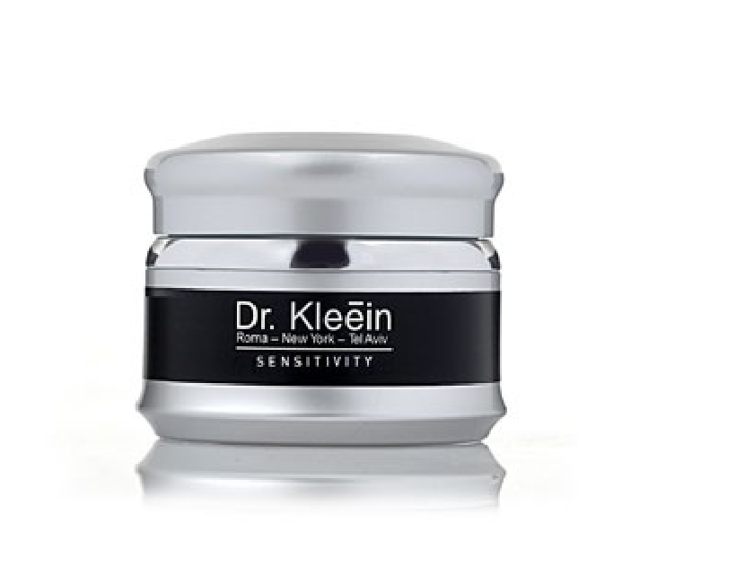
A gentle cream for delicate skin. Suitable for use after peeling treatments when the skin is sensitive and irritated, for skin with seborrhea, for skin that is sweat-prone, for oily skin, and for acne-prone skin during use of Roaccutane.
Contains: moisturizing ingredients, such as: Aloe Vera, Vitamin B5, Vitamin E and Antibacterial agents.
Fragrance and dye free.
Suitable for all skin types.
Ref.: 81017 - 50 ml
Ref.: 70001 - 250 ml

Neck And Décolleté Genetic Cream
An innovative and powerful active cream for intensive treatment of the neck and décolleté area.
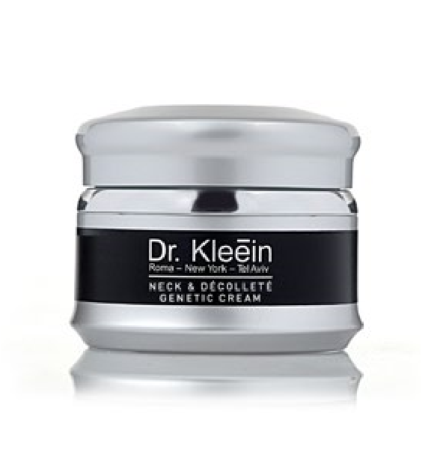
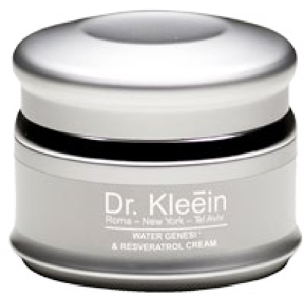
The cream’s advanced and unique formula promotes strengthening and firming of the skin, creates a uniform skin tone, minimizes and prevents pigmentation spots. Protects against environmental damage and the various causes of aging, nourishes, improves moisture levels. The skin on the neck and décolleté will look firm, smooth, and have a uniform skin tone.
Contains: Polyphenols (Anti-Oxidants), Proteins, Minerals, Vitamins A and B, Flax seed Oil (Omega 3, 6), Hyaluronic acid and Whitening agents.
Suitable for all skin types.
Ref.: 81027 - 50 ml

Resveratrol Proactive Cream
The cream is rich in very strong anti-oxidants to prevent premature aging of the skin.
Delivers immediate moisture to the skin, helps prevent premature aging of the skin, minimizes the appearance of wrinkles and fine lines, helps to prevent dryness and protects the skin’s elasticity.
Contains: Resveratrol (grape extract) and moisture boosting complexes such as Olive Oil, Vitamin E, and Hyaluronic acid.
**Paraben-free**
The cream is suitable for normal-dry skin.
Ref.: 80004 - 50 ml

Category: Serums

Cinzia Serum
A gentle serum with a rich velvety texture. The serum was developed using an advanced and unique technology. The serum’s action increases the penetration of active ingredients that are vital to protecting the skin against environmental damage.
Contains: Ester C (stable and permeable Vitamin C). Also contains Phytoestrogens, Natural salts and Vitamins. Suitable for all skin types.
Ref.: 81006 - 30 ml Ref.: 70007 - 100 ml

Active Serum
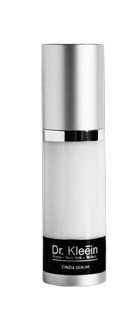
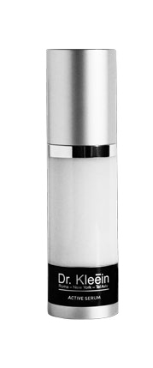
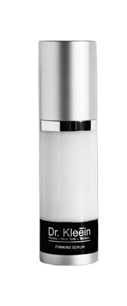
A unique serum rich in innovative, natural, and active ingredients that increase the skin’s moisture level, firms, minimizes wrinkles, and helps strengthen the skin’s natural defenses.The serum is enriched with a unique formula of Botanical Oils that are absorbed in the skin’s layers.
Contains: a high concentration of Hyaluronic Acid, vitamins, AntiOxidants, Soybeans, and Opuntia Extract (a rare cactus that grows in Mexico).
Regular use of the serum will revitalize and enrich the skin.
Suitable for all skin types, mainly for dry and dehydrated skin.
Ref.: 80000 - 30 ml Ref.: 70020 - 100 ml

Firming Serum
A concentrated and effective serum that helps with cell regeneration while increasing the skin’s firmness, suppleness and moisture levels. Strengthens and supports skin tissues. Causes immediate lifting and gives long-term results.
Contains: unique active ingredients like Peptides (Amino Acids) that accelerate collagen regeneration, Elastin and Hyaluronic Acid, Botanical Enzymes to increase permeability, Wheat Protein, Vitamin B3 and Grape extract.
Suitable for aging skin.
Ref.: 80002 - 30 ml

Resveratrol Proactive Serum
A concentrated powerful treatment to prevent premature aging and minimize the appearance of wrinkles and fine lines, leaves skin feeling smoother, helps lighten and even skin tone. The serum leaves skin looking firmer and smoother.
Contains: Resveratrol- a strong Anti-Oxidant found in the skin of Grapes and in Red wine, Peptides and other Anti-Oxidants.
**Paraben-free**
The serum is suitable for all skin types.
Ref.: 80003 - 30 ml

Whitening Serum
A powerful therapeutic product that contains a blend of unique active ingredients that inhibit and break down melanin. When used consistently over time you get a smoother, more uniform, lighter and healthier complexion.
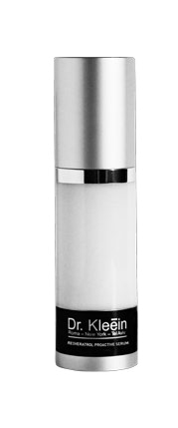
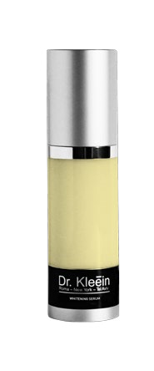
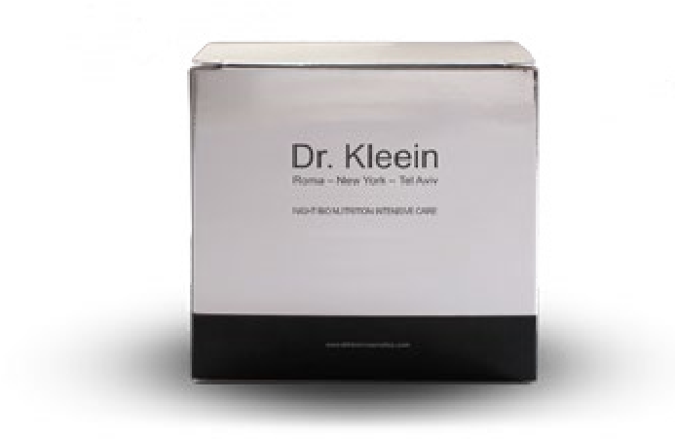
The serum is recommended as a supplemental treatment for all peeling treatments at the clinic and for the whitening treatments.
Contains: Glycolic acid, Kojic acid, Thyrostat, Allantoin, Licorice extract, Arbutin, yellow sorrel extract, Herbal extracts, Stable Vitamin C and Wheat Germ oil.
Suitable for all skin types. Ref.: 80001 - 30 ml

Category: Ampules

Night Bio Nutrition Intensive Care
A very rich formula that has 12 therapeutic nourishing oils that contain a complete complex of vitamins and fatty acids essential for the skin.
Increased nourishment and significant active and unique antioxidant action.
Suitable for normal to very dry skin.
Contains: Olive Oil, Avocado Oil, Sesame Oil, Sea Buckthorn oil, Evening Primrose Oil, Grape Seed oil, Pumpkin Oil, Lemon Oil, Orange Oil, Wheat Germ Oil, Vitamin E. Beta Carotene- Vitamin A.
Ref.: 50012 - 20 ml

Intensive Care- Antioxidant
Concentrated product with intensive activities developed as a result of the most highly advanced scientific technology. Stimulating skin renewal, boosting rehabilitation and supporting the skin tissue.
Contains: Protein, Minerals, Salt and Vitamins, White Tea Extract, Extract from several grape varieties, Argireline, Carob Beans, Gatuline Age Defense, GP4G and Optivegitol Wine.
Suitable for mature skin. Ref.: 60012 - 25 ml

Intensive Care- Lifting
Concentrated product with intensive activities developed as a result of the most highly advanced scientific technology. Simulating the Botox effect, the product minimizes fine lines and gives the skin a smoother, more toned look.
Contains: Hydrolastan, Minerals, salt and vitamins, White tea Extract, extract from several grape varieties, Argireline, Glycerin and Wheat Protein.
Suitable for mature skin. Ref.: 60011 - 25 ml

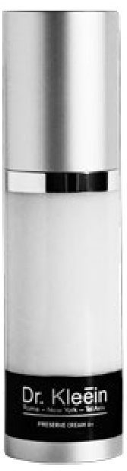
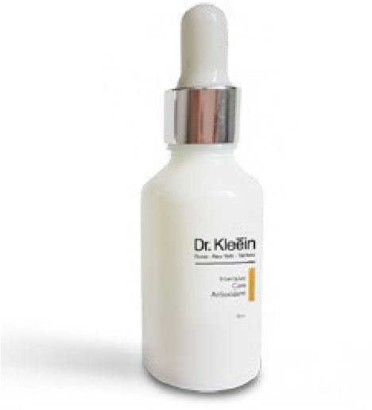
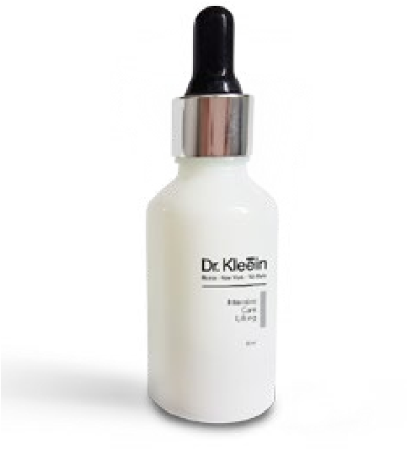
Category: Peels

Preserve Cream A+
A highly active therapeutic cream designed to treat signs of aging, combined with Alpha and Beta Hydroxy acids, The cream renews the skin, stimulates Collagen production, treats and minimizes fine lines.
Contains: Glycolic Acid, Lactic Acid, Mandelic Acid, Salicylic Acid, Retinyl Palmitate (derivative of Retin A), Anti-Oxidant Agents, Shea Butter, Alpha Lipoic Acids and Botanical Extracts.
Suitable for all skin types. For evening use only.
Ref.: 81014 - 50 ml

Replenishing Night Corrector
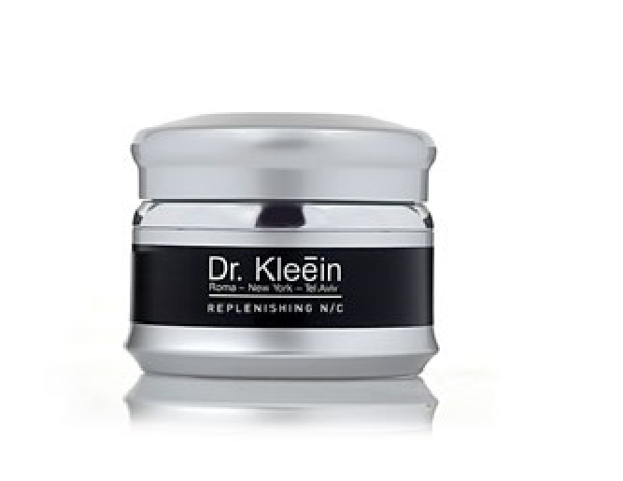
A very effective therapeutic product based on Glycolic acid and Green tea extract (a known anti-oxidant). Designed to remove dead skin cells, treat pigmentation issues (skin spots), rough skin, and lack of vitality. Regular use of the product raises the moisture levels in the deep layers of the skin, leaving skin looking healthy and radiant. Contains: Glycolic Acid, Green Tea
Suitable for all skin types. For evening use only.
Ref.: 81015 - 50 ml
Ref.: 60009 - 250 ml

AHA SPOT
A peeling gel based on a combination of Alpha and Beta Hydroxy Acids. For professional use only. Oil-free, Antiseptic, treats pimples on the face, back, chest and arms.
Contains: Azelaic Acid, Salicylic Acid, Vitamin C, Citric Acid, and Lemon Extract. Ref.: 50006 - 250 ml

4 Level Peel
A powerful and multi-purpose peel for all skin types and for a variety of therapeutic purposes. For professional use only.
Contains: BHA and AHA Acids, Glycolic Acid, Salicylic Acid, Mandelic Acid, Lactic Acid, Citric Acid, Kojic Acid, Azelaic Acid, and Lactobionic Acid.
Ref.: 60004 - 20 ml

Multi Effect Glycolic + Lactic 16%
A unique peeling solution that instantly dissolves corneal layer cells. In the long-term it promotes the accelerated production of Collagen and Elastin. Extremely effective in treating conditions of Aging, Acne, Seborrhea.
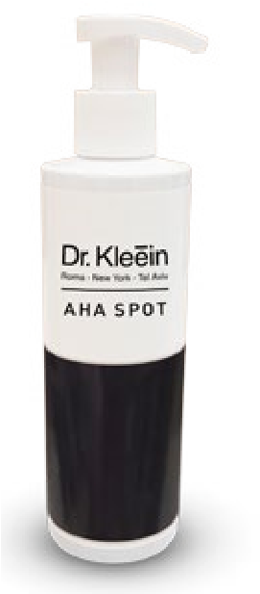
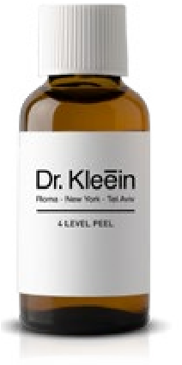
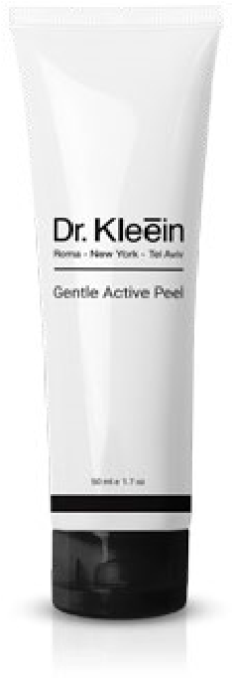
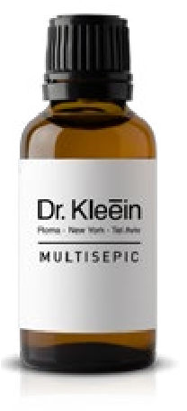
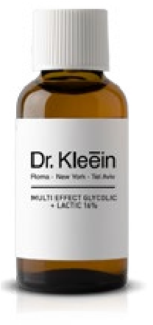
To be used as a course of treatment concurrent to home maintenance. The skin will look supple, vital, firm, and refreshed.
Contains: Glycolic Acid and Lactic Acid.
Ref.: 60008 - 50 ml

Gentle Active Peel
A gentle granular peel produced from coconut, prevents damage to the skin’s natural oils. Rich in active, nourishing, soothing, and moisturizing ingredients. Designed to remove the corneal cells without harming the skin’s natural oils. Leaves skin feeling smooth and refreshed without a sense of dryness.
Contains: Shea Butter, Lactic Acid, Vitamins E, B5, and Aloe Vera. Suitable for all skin types.
Ref.: 81024 - 50 ml Ref.: 50010 - 250 ml

Multisepic
An active therapeutic fluid. For drying, repairing, and disinfecting individual wounds only.
Contains: Alpha and Beta Hydroxy Acids, with a pH of 2.5.
Ref.: 50005 - 50 ml

Active Brightening Night Cream
A unique and highly effective brightening cream - whitens the skin and treats pigmentation spots. Based on very active ingredients that reduce the synthesis of Melatonin (skin pigment) and act synergistically with Alpha and Beta Hydroxy Acids promoting skin regeneration. Contains: Natural oils, Glycolic Acid, Glycerin, Lactic Acid, Kojic Acid, Silicil Acid.
Suitable for all skin types in small quantities. For evening use only.
Ref.: 81010 - 50 ml Ref.: 60005 - 250 ml

Pure Lactic Gel
A lactic acid-based night treatment to renew and firm the skin. Regular use of the product encourages collagen production in the deep layers of the skin and helps to improve the skin’s moisture absorption.
Contains: lactic acid produced from milk (whey). Helps to remove dead skin cells and to break down the intercellular glue between the layers. Suitable for all skin types as a night treatment only. Also suitable for people with dark complexions and for people with thin and delicate skin. Ref.: 81032 - 50 ml

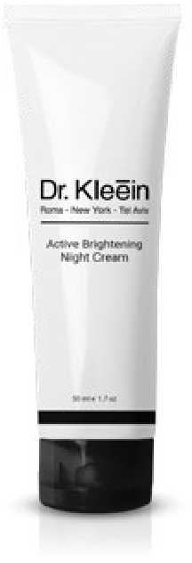
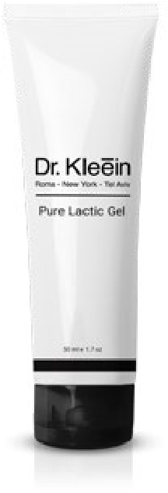
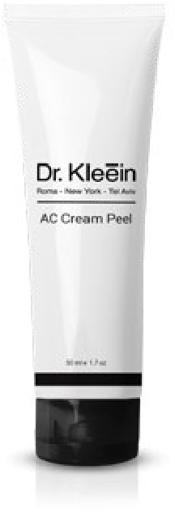
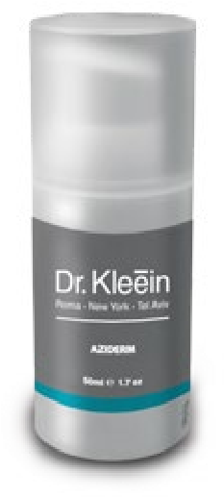
AC Cream Peel for Oily Skin
An active and oil-free alpha beta hydroxy cream to treat oily skin, problematic skin and post acne.
The product is antibacterial, anti-oxidant, regenerating, dissolves dead skin cells and balances sebum secretions.
Contains: AHA acids, Beta Hydroxy acid, Azelaic acid, Vitamin C and Herbal extracts.
The product is suitable for cases of acne and post acne Ref.: 81000 - 50 ml

Aziderm
A therapeutic product based on alpha and beta hydroxy acids, dominant azelaic acid. For problematic skin, post acne and whitening treatments. The product is designed to heal, disinfect and encourage skin regeneration, balance sebum secretions and maintain the skin’s hygiene, treat pustules, papules and infection, and improve skin tone and texture.
Contains: Lactic acid, Vitamin C + E, Salicylic acid, Azelaic acid, Glycolic acid, Kojic acid, Seaweed extract and Aloe Vera, Mandelic acid, Allantoin and Malic acid.
For evening use only, up to 3 times per week - during the daytime use a sunscreen with an SPF of at least 30.
The product is suitable for cases of acne and post acne.
Ref.: 81039 - 50 ml

On Spot Anti-Blemish Cream
A highly active product that works as a concealer while treating pimples and blemishes. For use in the morning and evening. Especially suitable for teenagers that want to cover up their pimples.
Absorbs excess oil, kills the bacteria that causes acne, heals the pimple and dries it while concealing it.
Contains: Manuka oil, Allantoin, Witch Hazel extract, Canadian Willowherb, AC net complex, Acnecidol.
The product is tinted and is suitable for blemished skin. Ref.: 81031 - 30 ml

Category: Body

Firming Body Cream
A body cream with a unique formula that combines nourishing and moisturizing ingredients. treats various skin conditions, such as: extreme dryness, irritation, and eczema, and it has anti-inflammatory and antibacterial properties. Another one of its advantages is repairing tissues, such as: burns, irritation, and post-operative infections.
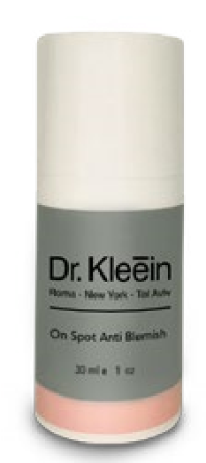
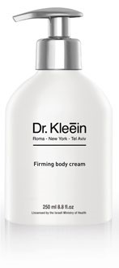
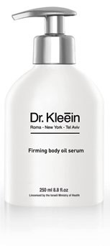
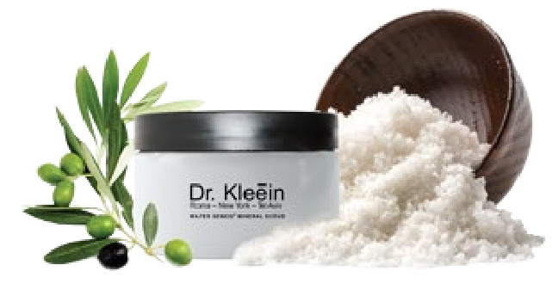
Contains: Almond Oil and Sea Buckthorn Oil, which is rich in fatty acids such as Omega 3, Omega 6, and Omega 9 and rich in Vitamin A, Aloe Vera, Allantoin, Dead Sea Minerals, and Vitamins B5 and E. Suitable for all skin types.
Ref.: 70015 - 250 ml

Firming Body Oil Serum
The body oil’s unique formula combines ingredients that nourish and rehabilitate the skin and promote normal functioning of the skin while maintaining suppleness and firmness.
The result is skin that looks healthy, soft, and velvety smooth, with an instant calming effect.
Contains: Olive Oil, Wheat Germ Oil, Avocado Oil, Almond Oil, Omega 3
Suitable for normal to dry skin.
Ref.: 70017 - 250 ml

Water Genesi Mineral Scrub
The product stimulates the skin to help neutralize the aging process.
Enriched with Anti-Oxidants like.
Leaves skin feeling soft and helps to even skin tone after tanning during the summer months.
Contains: Dead Sea Salts, Olive Oil.
Ref.: 745 - 250 ml

Category: Lotions

Calming Lotion
A therapeutic and delicate toner that soothes irritation and has an antiinflammatory effect to disinfect and rehabilitate. Suitable for all skin types. Fragrance and dye free. Treatment aims: soothe, rehabilitate, repair, and protect the skin’s hygiene.
Contains: Aloe Vera, Chamomile, Allantoin, Idibinone.
Ref.: 50011 - 250 ml

Deep Removal
A volatile liquid that disinfects and dissolves oils from the skin (degreasing) prior to peeling.
Contains: Natural Alcohol and Citrus Extracts.
Ref.: 50003 - 250 ml

Lotion Tonic For Oily Skin
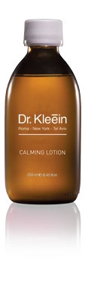
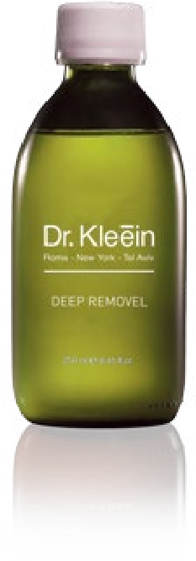
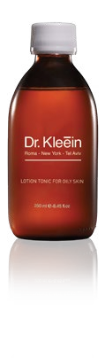
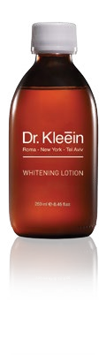
A unique facial toner formula for purifying, regenerating, and disinfecting the skin, dissolving sebum secretions and shrinking pores.
Contains: Alcohol, Chamomile Extract, Vitamin C, Dead Sea Minerals, Hamamelis (Witch Hazel) Extract (Shrinks, Absorbs, and AntiInflammatory), and Seaweed Extract. Suitable for oily or problematic skin. Ref.: 50018 - 125 ml

Whitening lotion
A highly unique and active product for daily use, improves the skin’s overall tone, whitens age spots, sun spots, and promotes cell regeneration.
The lotion works in two ways:Gentle peeling to improve the skin’s texture and breaking down existing Melanin and inhibiting the production of new Melanin.
Contains: Licorice, Lemon Extract, Arbutin, Glycolic Acid, Lactic Acid, Vitamin C, Kojic Acid, and more..
Suitable for all skin types, according to varying doses and the treating cosmetician's instructions.
Ref.: 44001 - 125 ml
Ref.: 55001 - 250 ml

Category: Unique Products

Rebuilding Gel
The gel contains vitamin capsules that serve as powerful repairing agents and active ingredients that address different skin conditions.
Contains: Encapsulated Vitamins A, B5, E, Chamomile Flower Extract, Hyaluronic Acid, Urea, Allantoin, Aloe Vera.
Ref.: 81016 - 50 ml Ref.: 70000 - 250 ml

Relaxing Gel
An active relaxing gel combined with Anti-Oxidant extracts. The gel soothes irritation, disinfects, moisturizes and neutralizes acidity. Has a pH of 8.5. It also plumps up the skin prior to deep cleansing and works wonderfully when added to any aqueous-based massage mixture.
Contains: Aloe Vera, Allantoin, Chamomile Extract, Green Tea Extract, Sea Weed Extract, Idibinon, Vitamins- A, E and C.
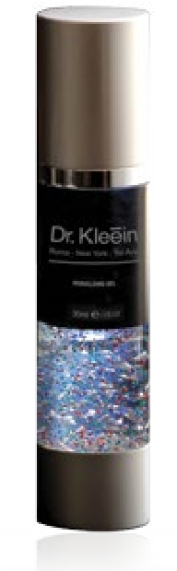
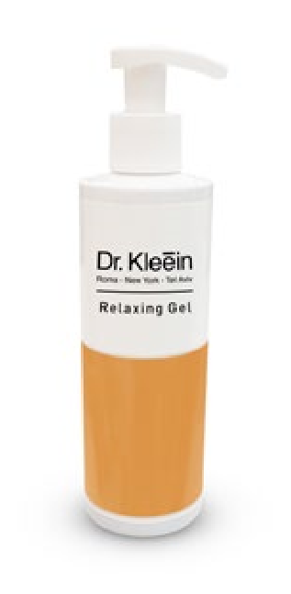
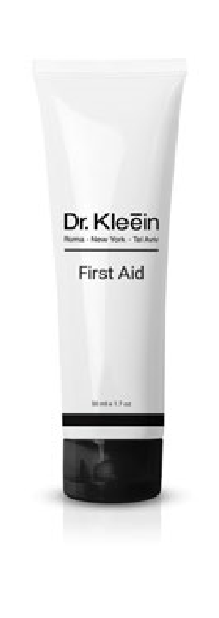
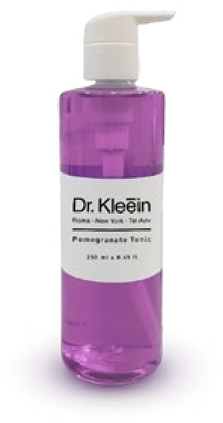
Ref.: 50004 - 250 ml

First Aid Cream
A 100% natural cream that, treats infections, Designed to disinfect wounds, heal, repair and rehabilitate scars. Immediate treatment of burns, treats bruises, rapid repair of tissues, immediate treatment of Irritations, Rash, Eczema, Stings, Pressure sores, Chaffing, and Fungi (Antiseptic and Anti-Bacterial), treats Jellyfish stings.
Contains: more than 100 active botanical ingredients, special essential oils and nourishing oils
Excellent for use after permanent makeup treatments, hair removal treatments on the face and body.
Ref.: 81009 - 50 ml Ref.: 50016 - 250 ml

Pomegranate Tonic
A moisturizing liquid that cleanses, heals, soothes, and refreshes the skin.
Contains: A high concentration of Pomegranate Extract, Anti-Oxidants, Anti-Inflammatory ingredients, soothing extracts and Vitamin B5 to strengthen the skin’s defense system.
Ref.: 50017 - 250 ml

Breast Treatment Cream
A unique cream designed to nourish, firm, and improve the elasticity of breast tissue and décolletage. A revolutionary scientific development that contains unique and highly effective active. Regular and prolonged use will result in a significant improvement.
Applying the cream during the initial stages of pregnancy will reduce the appearance of stretch marks.
Contains: Essential fatty acids, Pantothenol, Allantoin, - Oligopeptides and Tetrapeptides, Minerals, Aloe Vera, Tocopheryl acetate.
Regular application as per the instructions will result in a significant improvement within 60 days. Ref.: 70016 - 250 ml
Category: Super Food

For professional use only

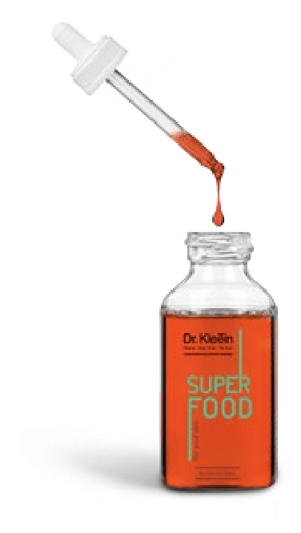
Nutri Intense
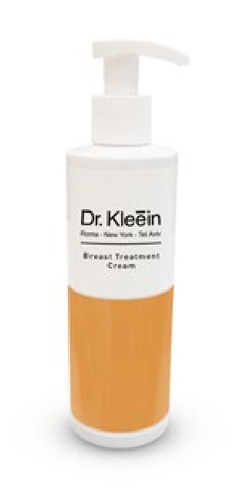
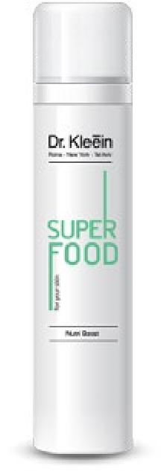
A powerful complex of essential oils rich in beta carotene, omega 3+6 fatty acids renowned for their ability to provide deep nourishment, impart a radiant complexion, maintain skin health, vitality and a youthful appearance. Provides the skin with available and essential energy by stimulating biological processes. Strengthens the skin and its resistance to environmental damage.
Alleviates signs of “urban fatigue”.
Contains: Lycomega, Lycopene, Omega 3 and 6 fatty acids,
Tocotrienols, Tocopherols, Raspberry oil, Calendula oil, Avocado oil, Sea buckthorn oil, Rosehip oil.
Paraben free Ref.: 60018 - 50 ml

Nutri Boost
A concentrated treatment based on a powerful complex of super food ingredients such as spirulina and goji berry - renown for their ability to provide fast and available energy to maintain skin health, vitality and a youthful appearance.
Provides the skin with available and essential energy by stimulating biological processes.
Strengthens the skin and its resistance to environmental damage. Alleviates signs of “urban fatigue”.
Contains: Pentavitin, Spirulina, Goji Berry, Bladderwrack, Green Tea.
Paraben free
Ref.: 60019 - 100 ml

Nutri Cream
A rich and velvety textured cream based on a powerful complex of super food ingredients such as spirulina, goji berry, lycopene and omega 3+6 fatty acids - renown for their ability to provide fast and available energy to maintain skin health, vitality and a youthful appearance. Provides the skin with available and essential energy by stimulating biological processes.
Strengthens the skin and its resistance to environmental damage. Alleviates signs of “urban fatigue”.
Contains: Oat lipid, Lycomega, Lycopene, Omega 3 and 6 fatty acids, Tocotrienols, Tocopherols, Spirulina, Goji Berry, Raspberry Oil, Almond oil, Evening Primrose oil, Jojoba oil, Vitamin E.
Paraben free Ref.: 60020 - 250 ml Nutri Peel
A unique botanical peel produced from five types of plants.
The peel warms the skin, resulting in a rapid flow of blood that stimulates metabolism, toxin cleansing, as well as helps to heal, stimulate, regenerate, and improve the quality of the skin.
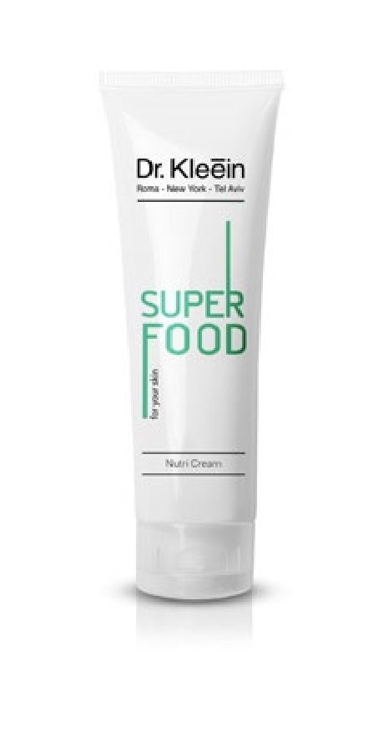
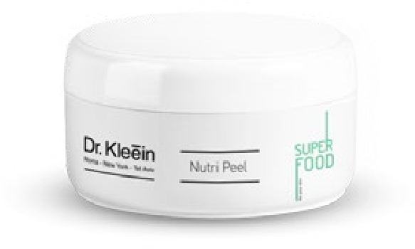
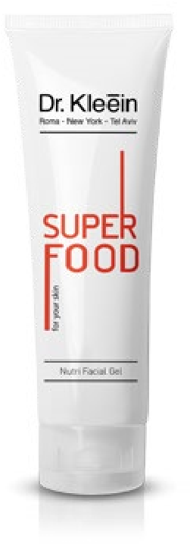
Contains: Lemon-scented Geranium, Za’atar, Cardamom, Rosemary, Peppermint.
Despite the warming effect, the peeling is suitable for broken capillaries, diabetic patients, people with high blood pressure, acne and oily skin, before deep cleansing, oily and dry seborrhoea, before an event, and for day to day skin care.
Paraben free Ref.: 60021 - 250 ml

Nutri Facial Gel
A massage gel enriched with hyaluronic acid and super food ingredients such as spirulina and goji berry - renown for their ability to provide fast and available energy to protect skin health, vitality and a youthful appearance. Acts as an excellent carrier for specific supplements such as: active ampoules and oils, depending on the treatment goal at the clinic. A massage gel enriched with hyaluronic acid and super food ingredients such as spirulina and goji berry - renown for their ability to provide fast and available energy to protect skin health, vitality and a youthful appearance. Acts as an excellent carrier for specific supplements such as: active ampoules and oils, depending on the treatment goal at the clinic.
Contains: Hyaluronic acid, Glycosaminoglycan, Unimoist, Spirulina, Goji Berry, Calendula extract. Paraben free
Ref.: 60022 - 250 ml

Nutri Fruit Peel
An enzymatic peeling in the form of a gel, designed to help accelerate the skin cell renewal process and improve skin texture.
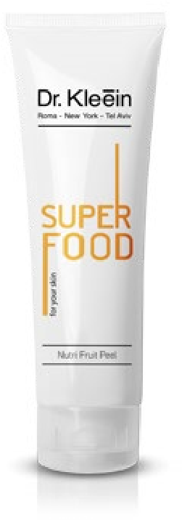
Helps to remove dead skin cells, maintain the skin’s suppleness and softness, prepares the skin for subsequent treatments.
Contains: Pineapple and Papaya Enzymes
Paraben free
Ref.: 60023 - 250 ml

